Silhouette metric for img011001.jpg is: 0.42858376808477117

Davies Bouldin metric for img011001.jpg is: 0.3809771120733906

Calinski Harabasz metric for img011001.jpg is: 4798.004908924354

ID 0: (103, 477)

ID 1: (998, 373)

ID 2: (890, 656)

ID 3: (934, 863)

ID 4: (1374, 557)

ID 5: (1556, 450)

ID 6: (1736, 445)

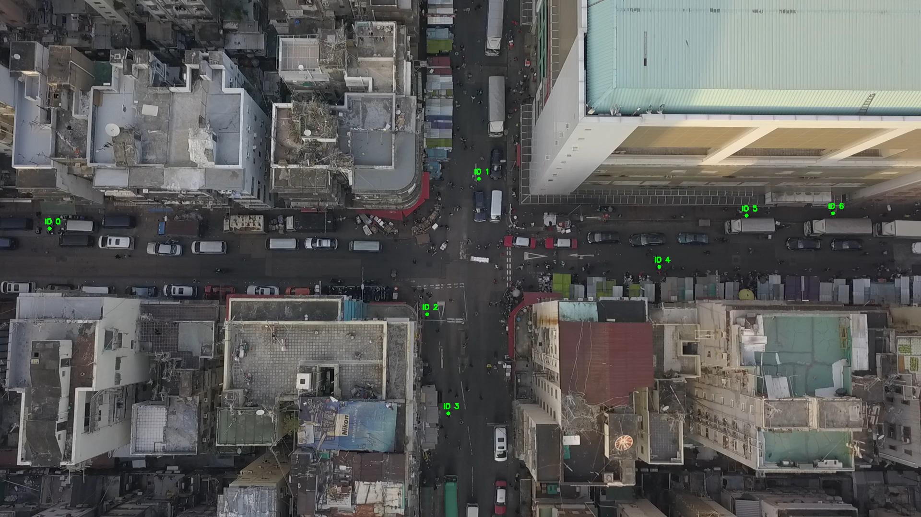

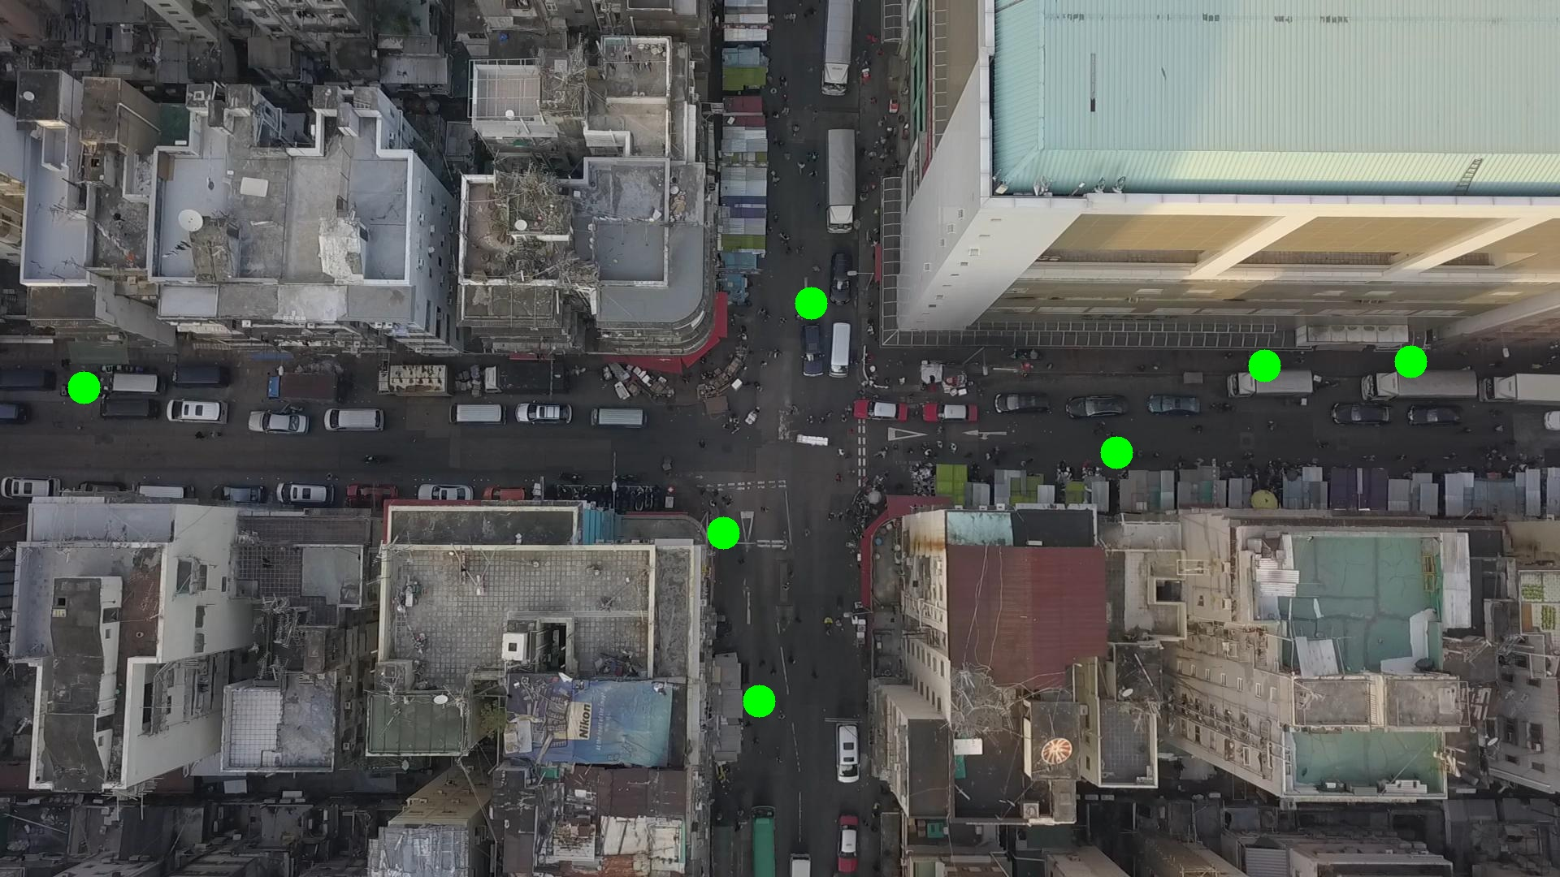

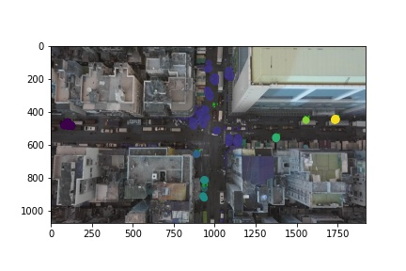

Silhouette metric for img011002.jpg is: 0.6040040091533364

Davies Bouldin metric for img011002.jpg is: 0.34893089788433895

Calinski Harabasz metric for img011002.jpg is: 9450.219891736679

ID 0: (102, 479)

ID 1: (977, 298)

ID 2: (890, 655)

ID 3: (936, 844)

ID 4: (1373, 559)

ID 5: (1551, 448)

ID 6: (1736, 445)

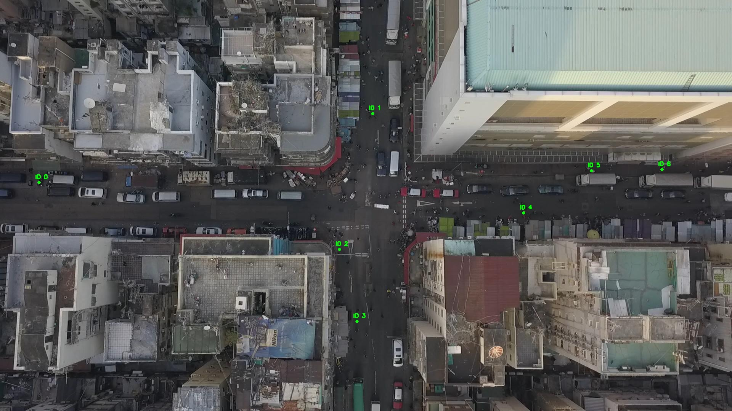

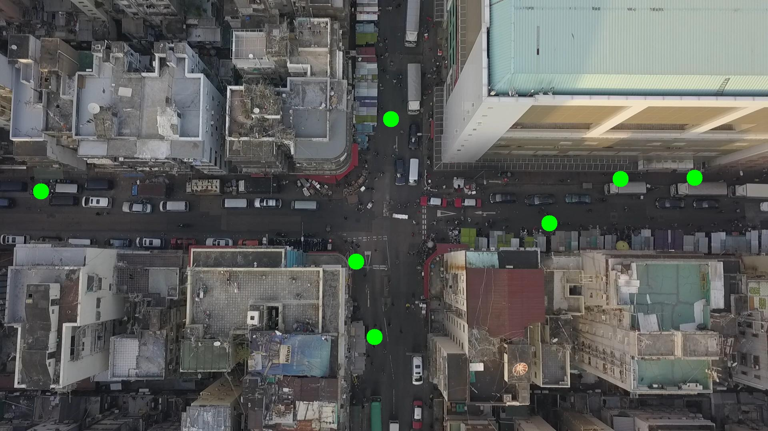

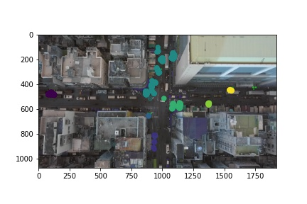

Silhouette metric for img011003.jpg is: 0.4156800632484144

Davies Bouldin metric for img011003.jpg is: 0.3624190716599271

Calinski Harabasz metric for img011003.jpg is: 4022.3872742865747

ID 0: (100, 479)

ID 1: (997, 351)

ID 2: (890, 656)

ID 3: (937, 831)

ID 4: (1376, 555)

ID 5: (1562, 451)

ID 6: (1736, 445)

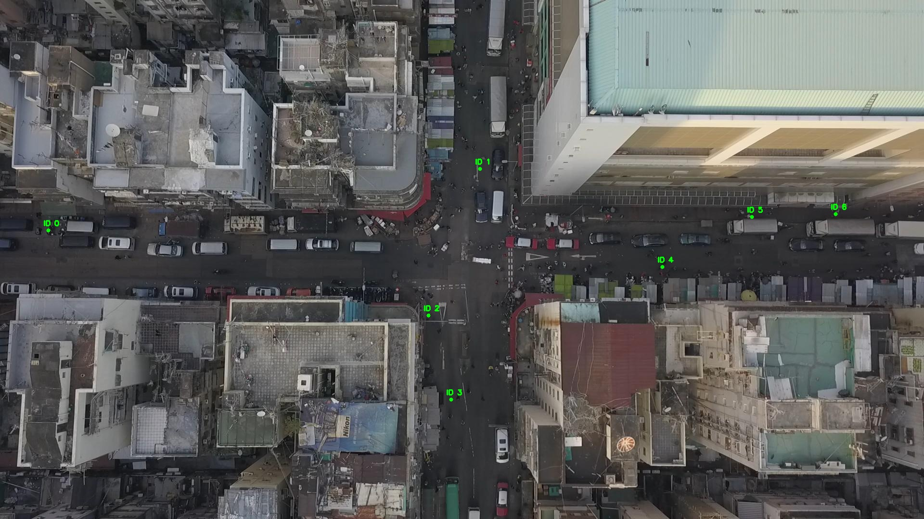

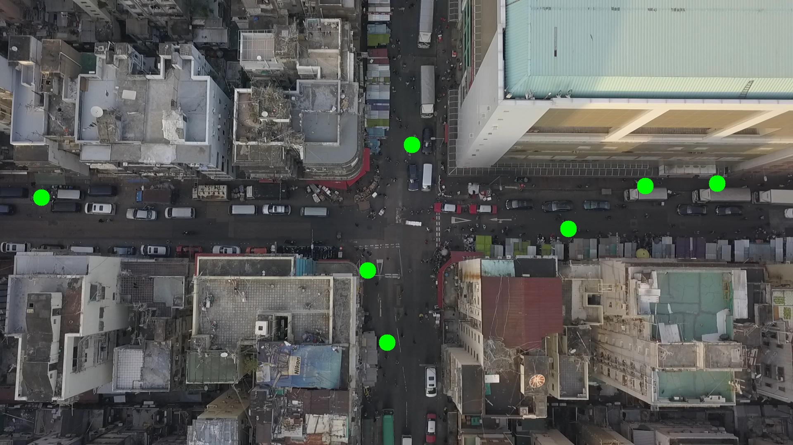

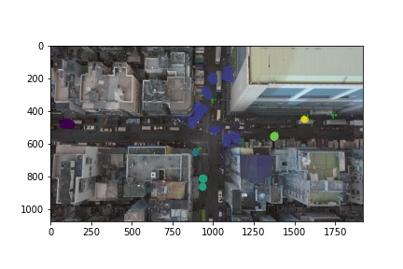

Silhouette metric for img011004.jpg is: 0.43488543630187826

Davies Bouldin metric for img011004.jpg is: 0.3633772373040829

Calinski Harabasz metric for img011004.jpg is: 4790.174198768267

ID 0: (101, 478)

ID 1: (998, 344)

ID 2: (890, 655)

ID 3: (937, 814)

ID 4: (1359, 544)

ID 5: (1562, 451)

ID 6: (1736, 445)

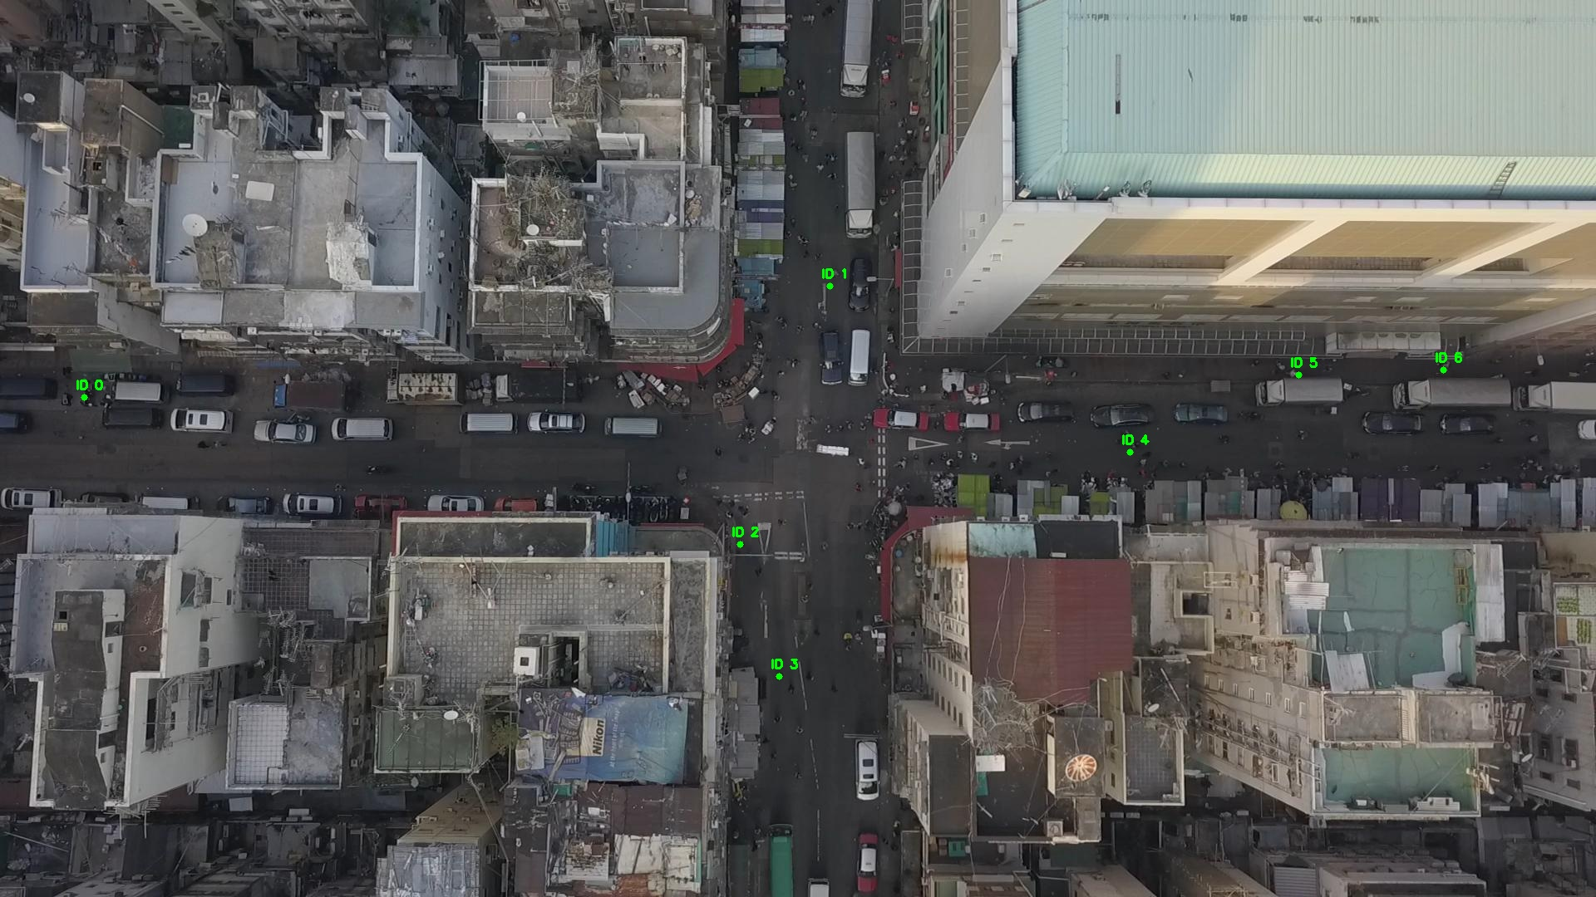

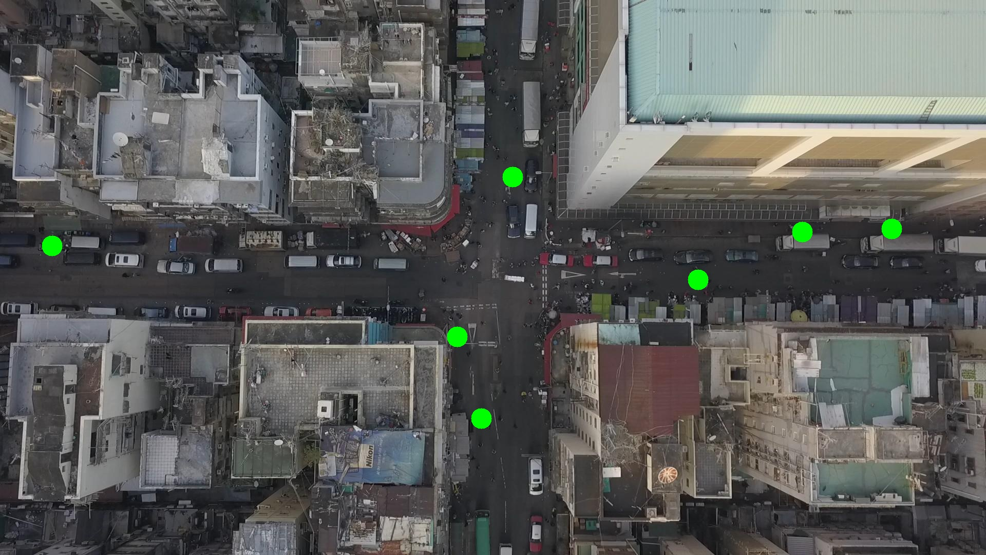

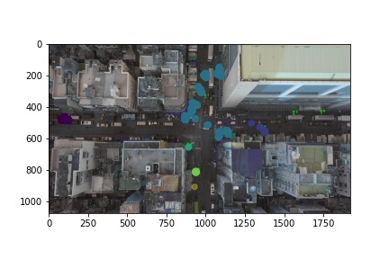

Silhouette metric for img011005.jpg is: 0.4000061935113386

Davies Bouldin metric for img011005.jpg is: 0.45079390067606406

Calinski Harabasz metric for img011005.jpg is: 10213.905909771811

ID 0: (103, 477)

ID 1: (1014, 364)

ID 2: (891, 654)

ID 3: (935, 862)

ID 4: (1376, 555)

ID 5: (1562, 451)

ID 6: (1736, 445)

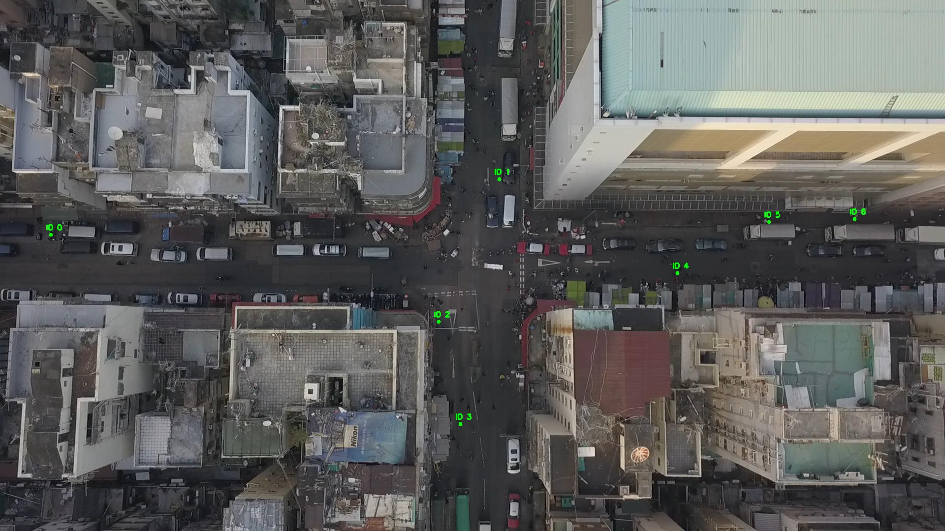

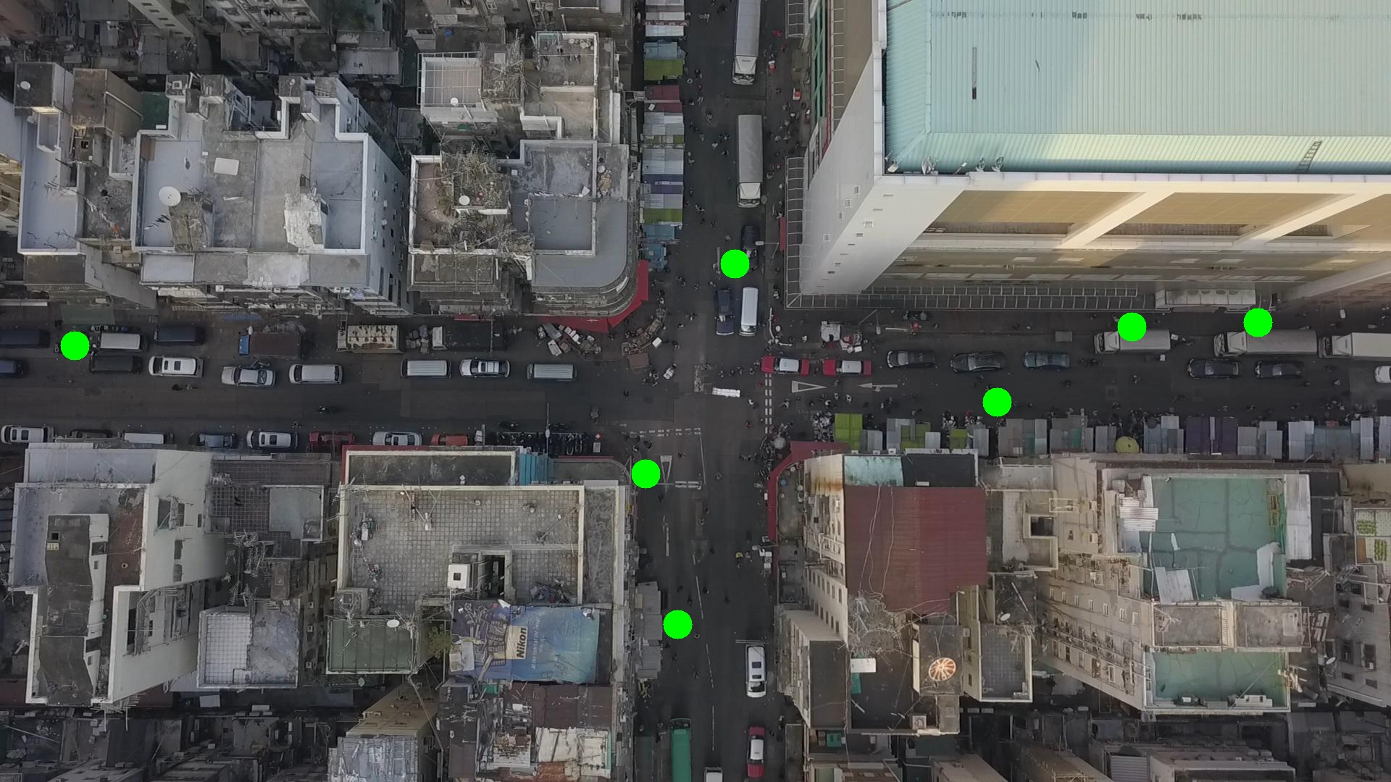

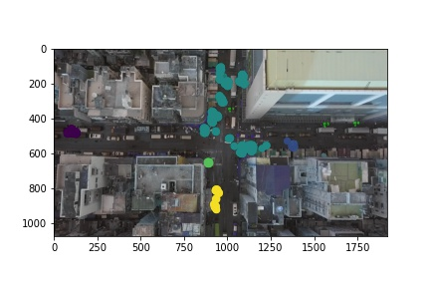

Silhouette metric for img011006.jpg is: 0.3701883360449924

Davies Bouldin metric for img011006.jpg is: 0.4873454663648216

Calinski Harabasz metric for img011006.jpg is: 13303.981213670797

ID 0: (103, 478)

ID 1: (1016, 368)

ID 2: (892, 655)

ID 3: (938, 858)

ID 4: (1362, 539)

ID 5: (1562, 451)

ID 6: (1736, 445)

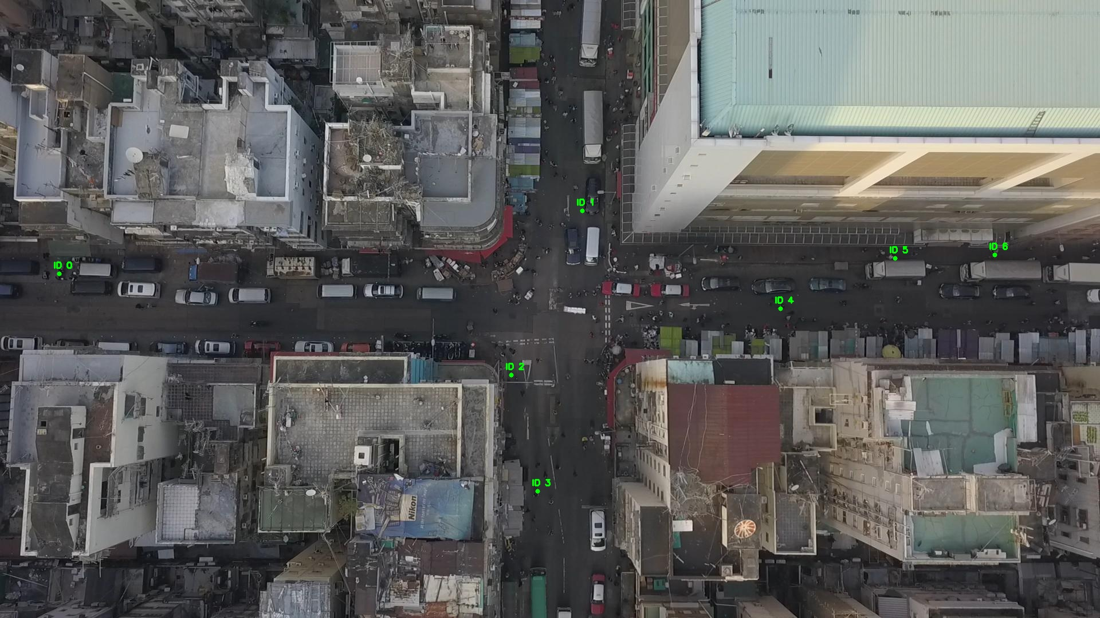

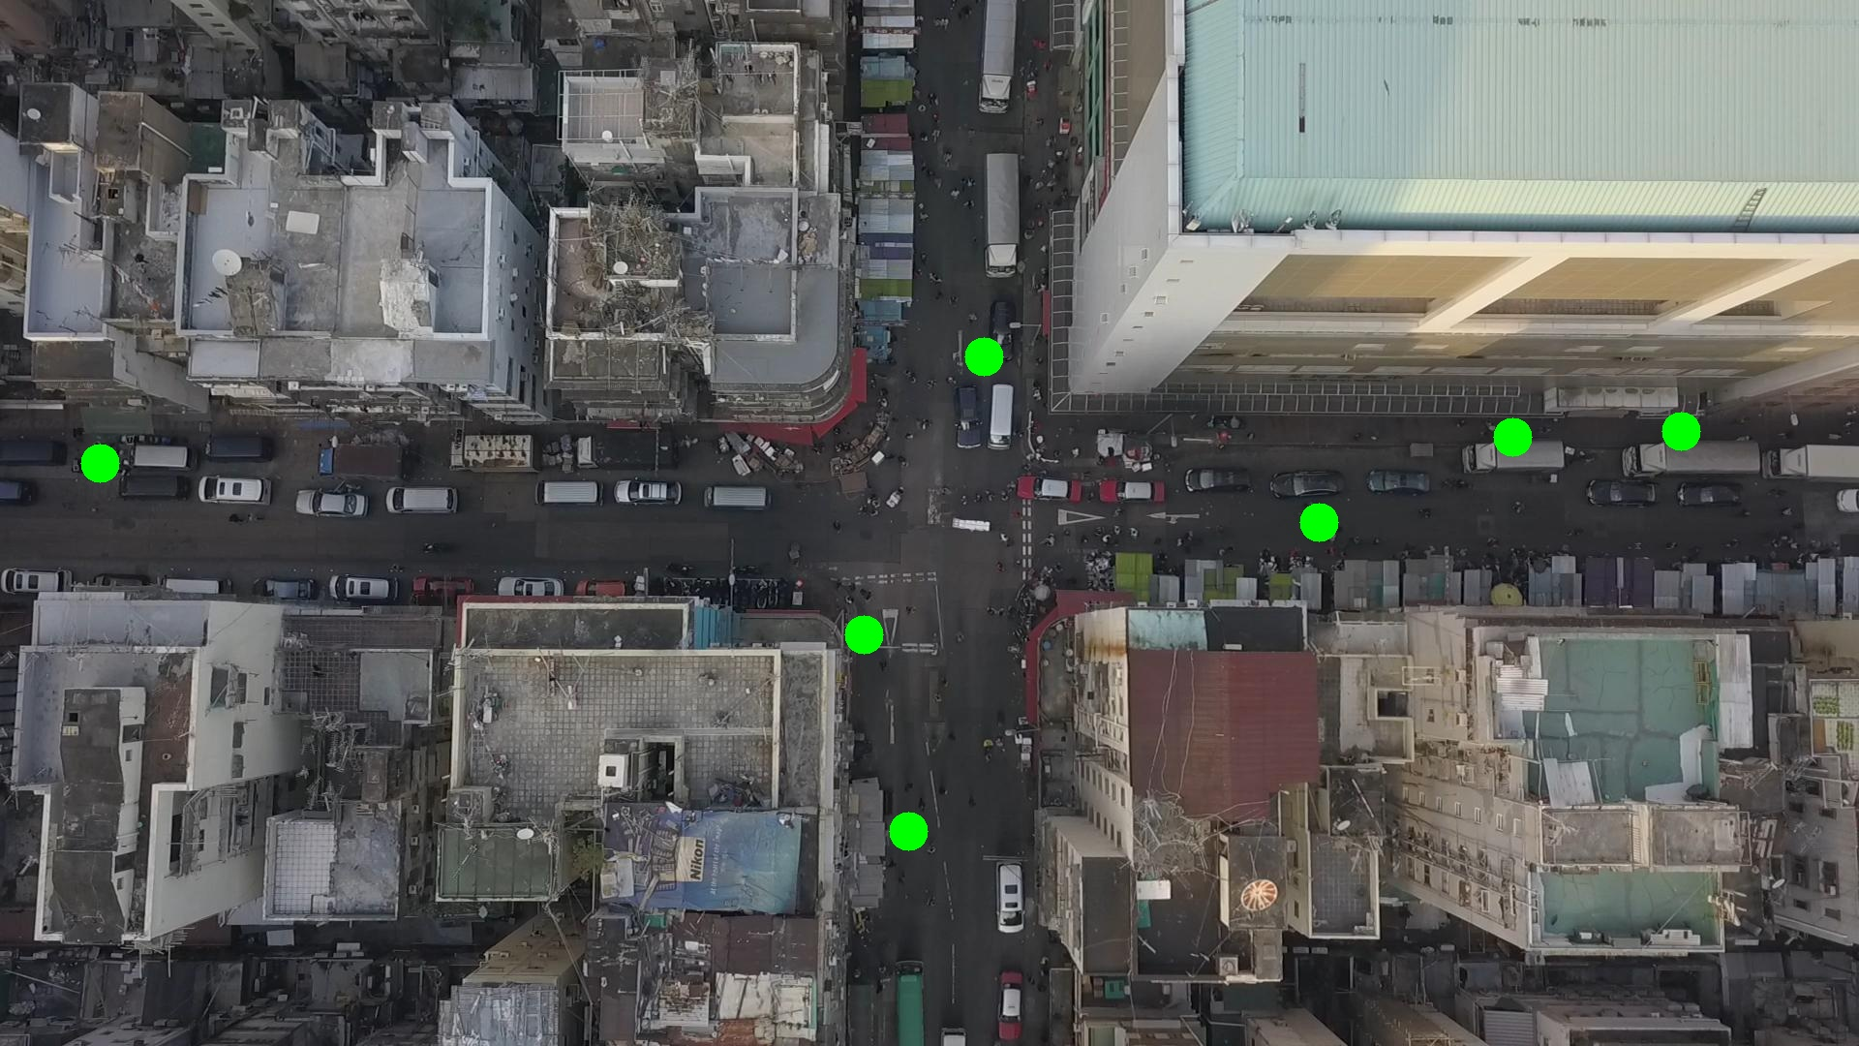

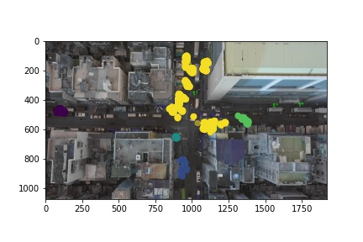

Silhouette metric for img011007.jpg is: 0.5936020909813552

Davies Bouldin metric for img011007.jpg is: 0.37949037786403533

Calinski Harabasz metric for img011007.jpg is: 28253.538501861614

ID 0: (103, 477)

ID 1: (976, 277)

ID 2: (892, 654)

ID 3: (938, 865)

ID 4: (1367, 543)

ID 5: (1562, 451)

ID 6: (1736, 445)

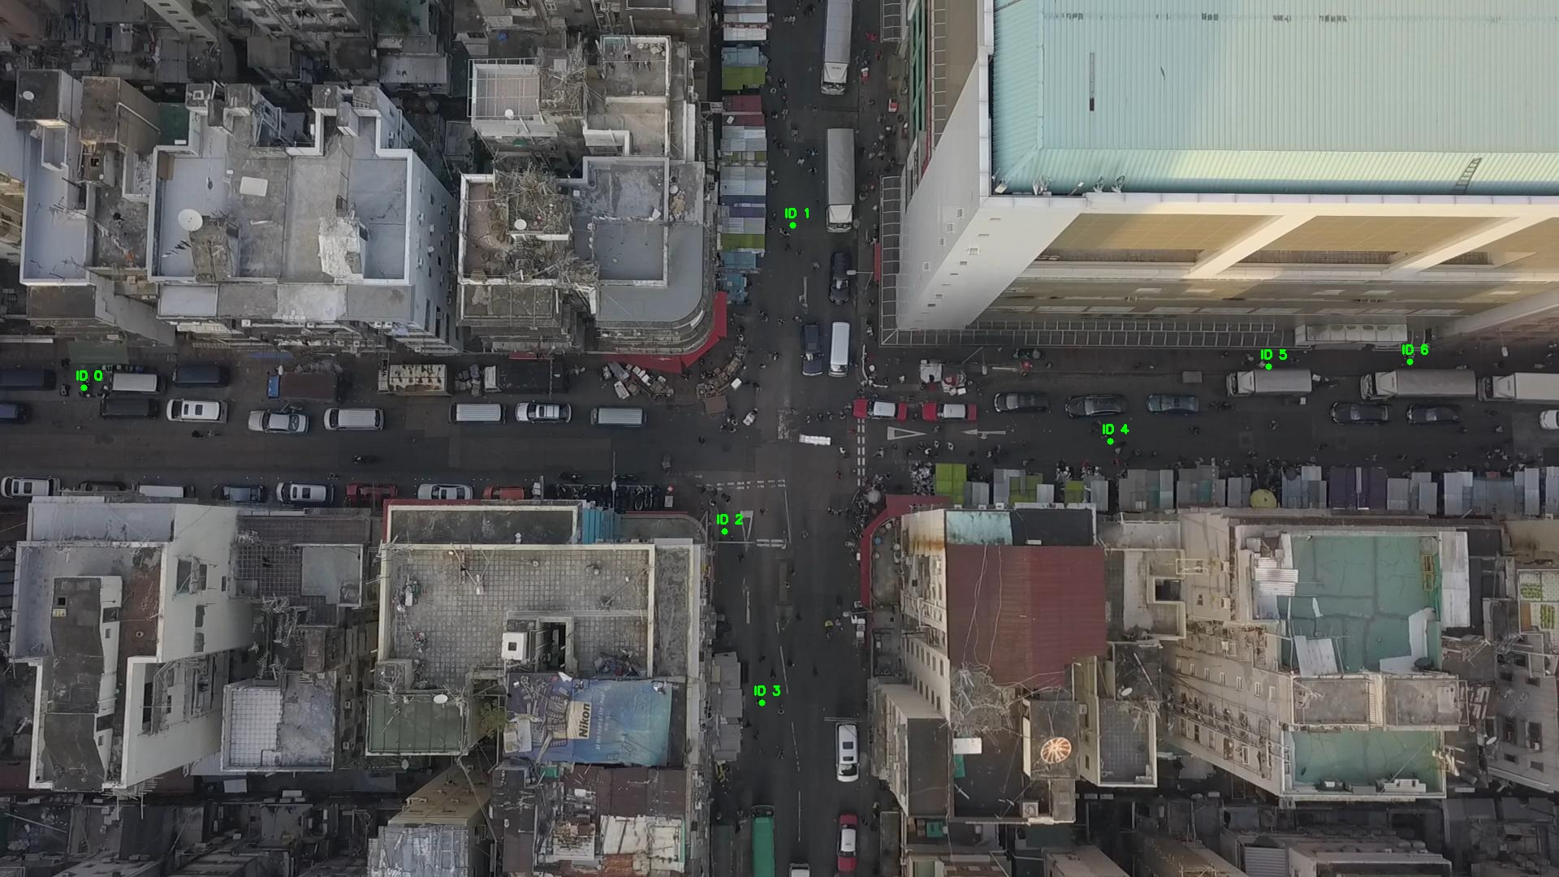

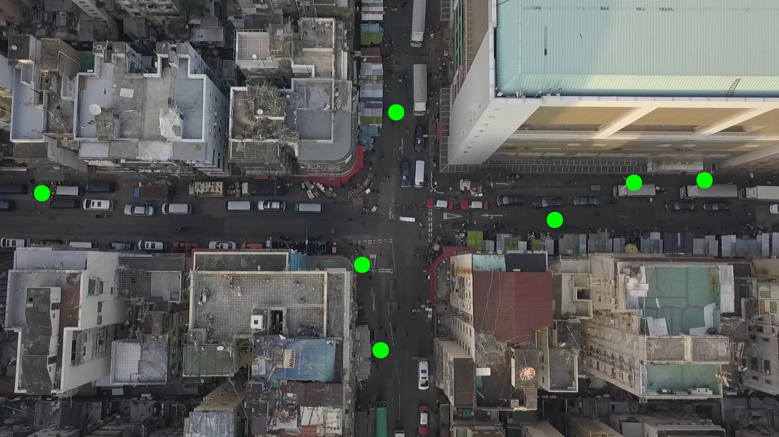

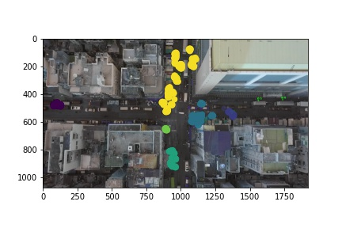

Silhouette metric for img011008.jpg is: 0.585959889053308

Davies Bouldin metric for img011008.jpg is: 0.3670602438770995

Calinski Harabasz metric for img011008.jpg is: 19705.110743557023

ID 0: (103, 478)

ID 1: (976, 280)

ID 2: (892, 653)

ID 3: (936, 864)

ID 4: (1368, 547)

ID 5: (1530, 451)

ID 6: (1736, 445)

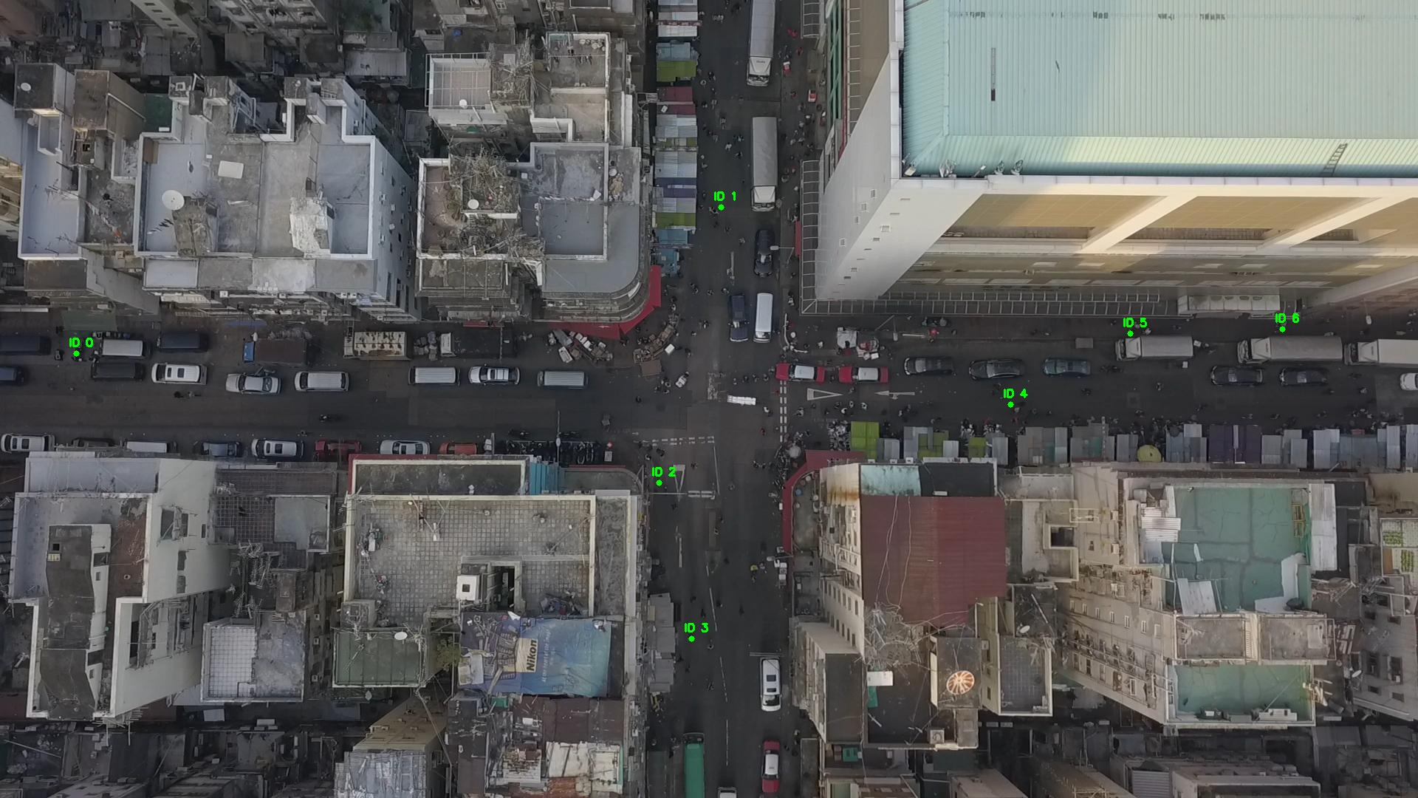

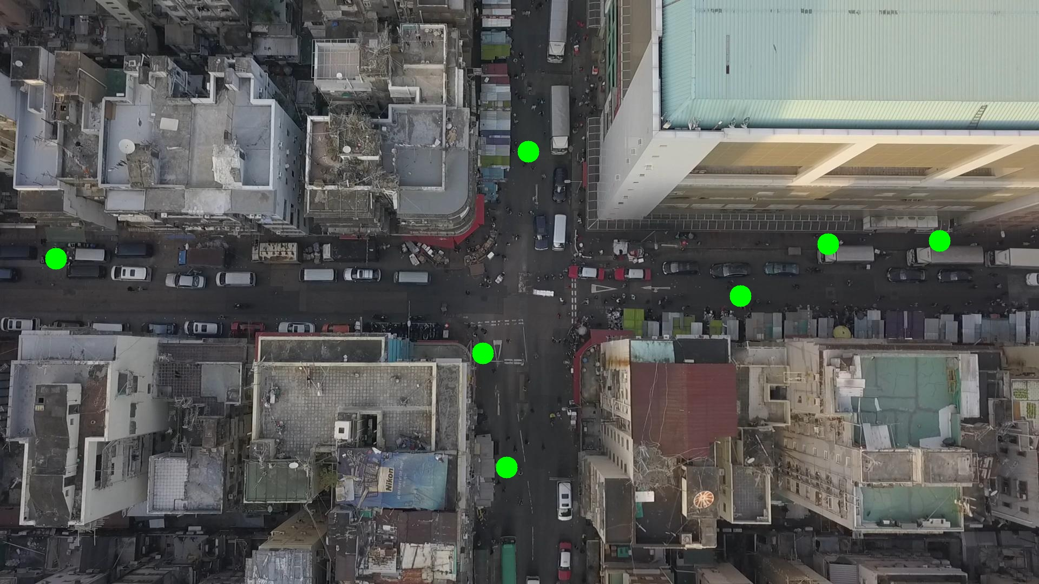

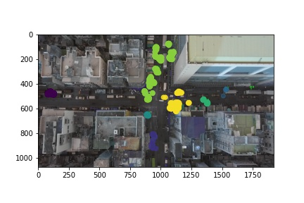

Silhouette metric for img011009.jpg is: 0.619785994269997

Davies Bouldin metric for img011009.jpg is: 0.3149182769928583

Calinski Harabasz metric for img011009.jpg is: 22667.811780325217

ID 0: (104, 477)

ID 1: (968, 291)

ID 2: (891, 651)

ID 3: (938, 862)

ID 4: (1373, 549)

ID 5: (1530, 447)

ID 6: (1736, 445)

ID 7: (1120, 578)

ID 8: (1235, 1044)

ID 9: (1073, 1007)

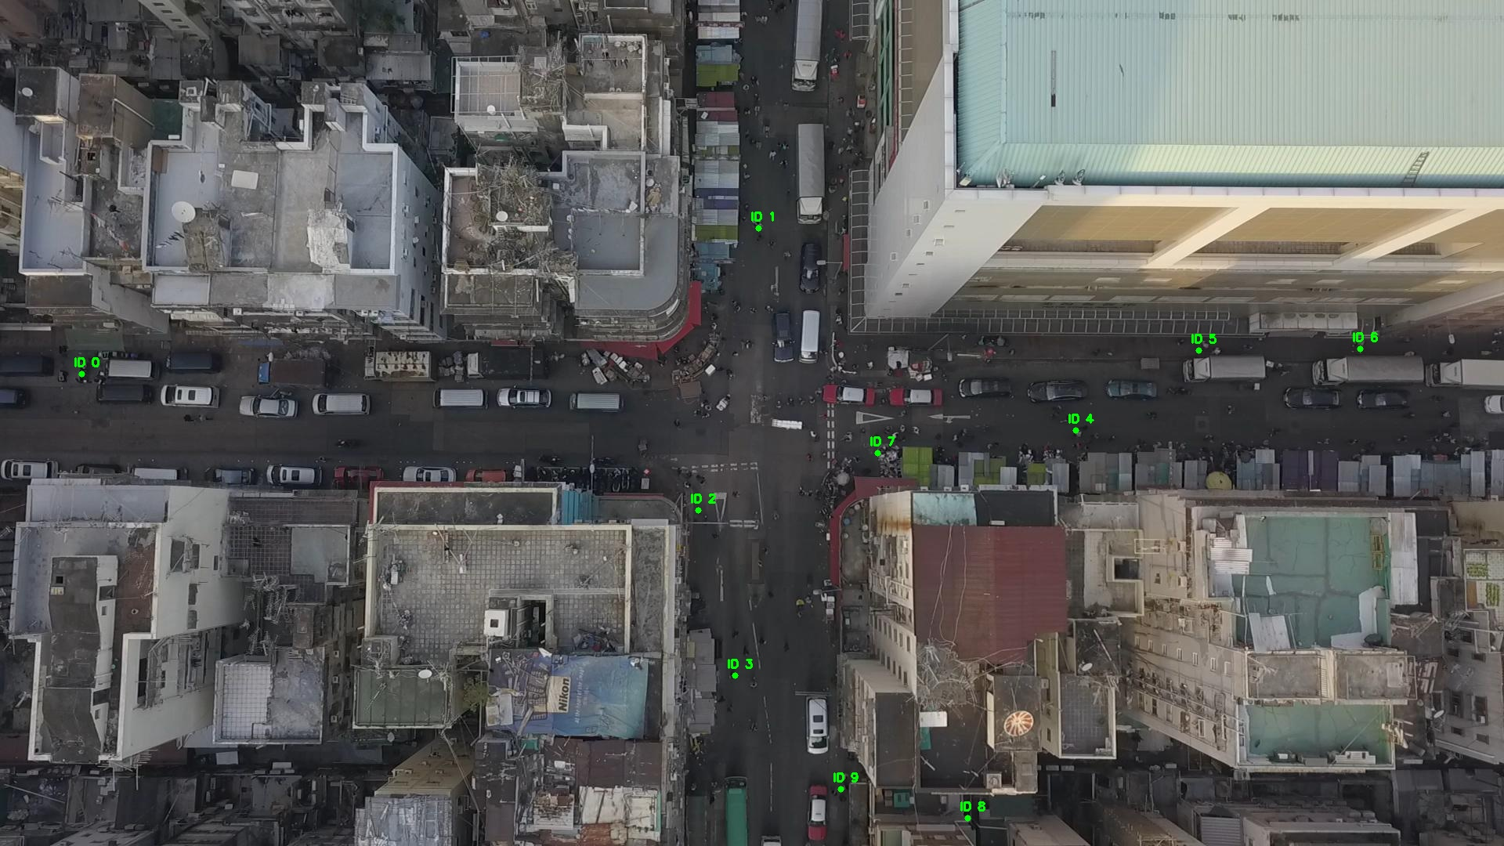

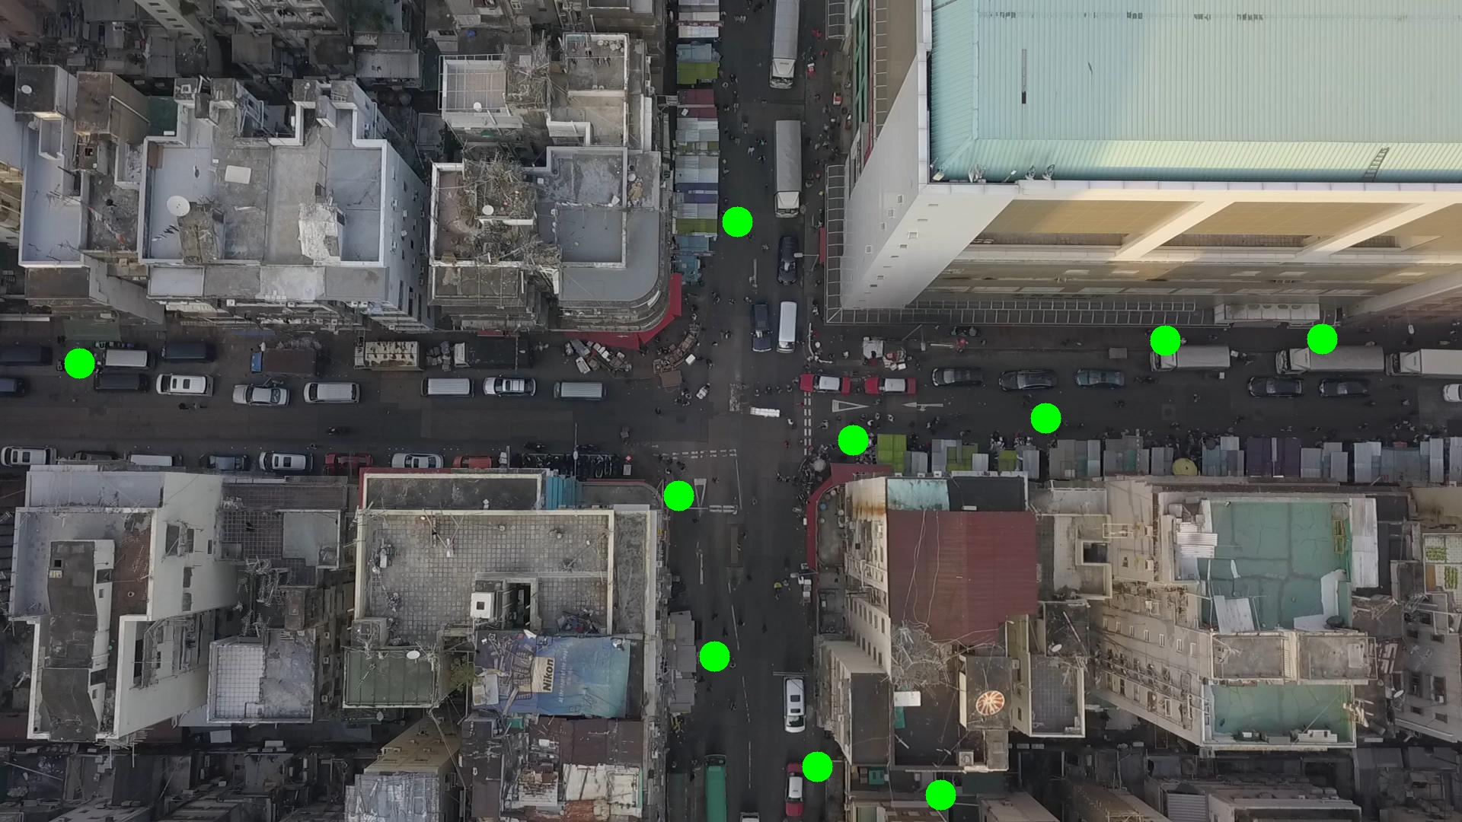

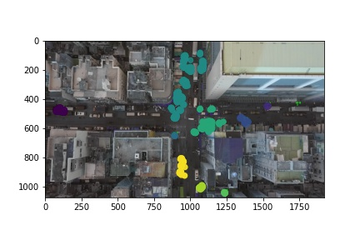

Silhouette metric for img011010.jpg is: 0.5462783473971732

Davies Bouldin metric for img011010.jpg is: 0.39711550525965483

Calinski Harabasz metric for img011010.jpg is: 19606.59229087873

ID 0: (104, 478)

ID 1: (968, 297)

ID 2: (893, 653)

ID 3: (939, 850)

ID 4: (1373, 549)

ID 5: (1530, 447)

ID 6: (1736, 445)

ID 7: (1189, 563)

ID 8: (1237, 1045)

ID 9: (1072, 1006)

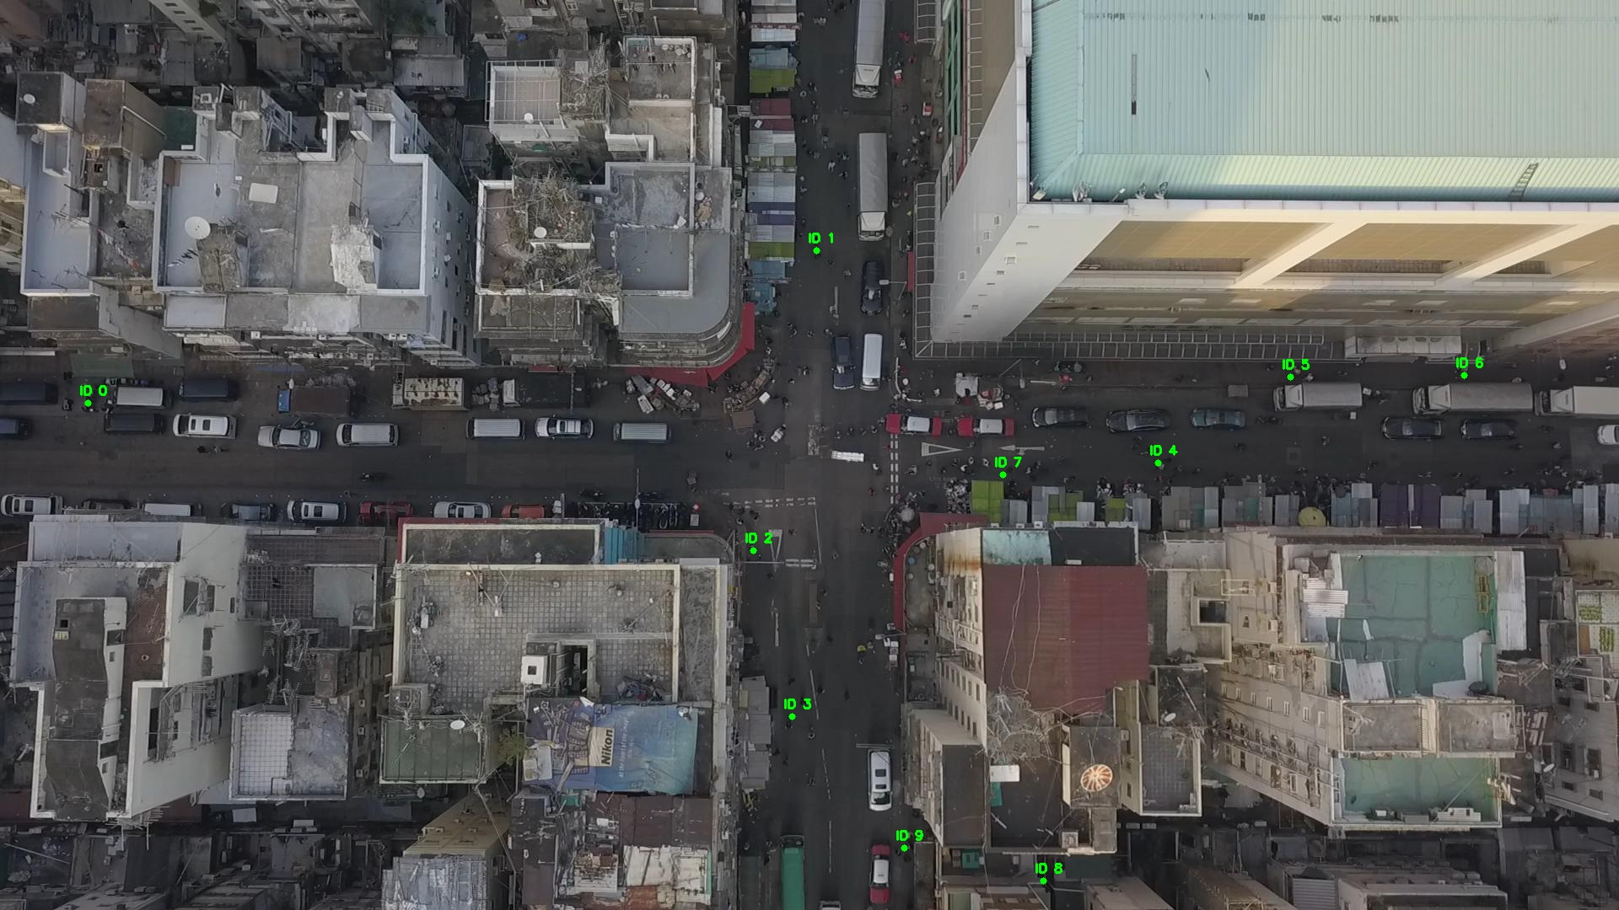

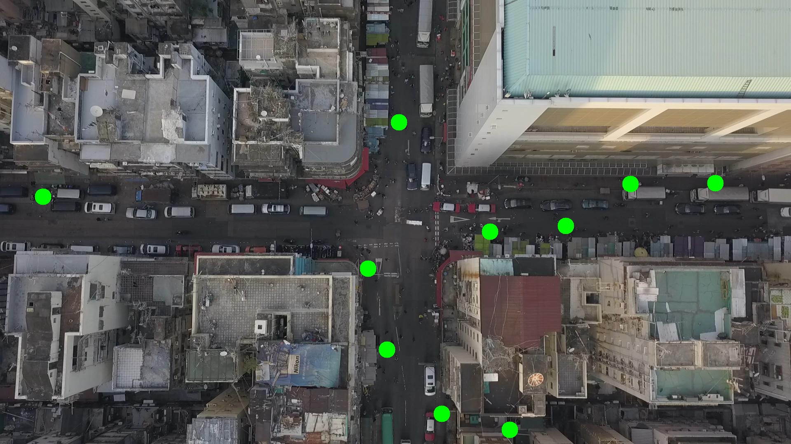

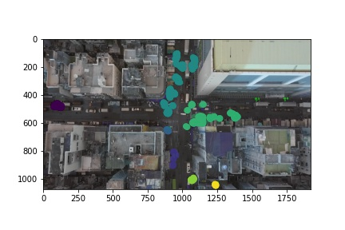

Silhouette metric for img011011.jpg is: 0.5735358648741645

Davies Bouldin metric for img011011.jpg is: 0.34930899179188435

Calinski Harabasz metric for img011011.jpg is: 21195.28190394902

ID 0: (103, 477)

ID 1: (987, 261)

ID 2: (892, 651)

ID 3: (941, 865)

ID 4: (1373, 549)

ID 5: (1530, 447)

ID 6: (1850, 554)

ID 7: (1202, 565)

ID 8: (1237, 1046)

ID 9: (1069, 1010)

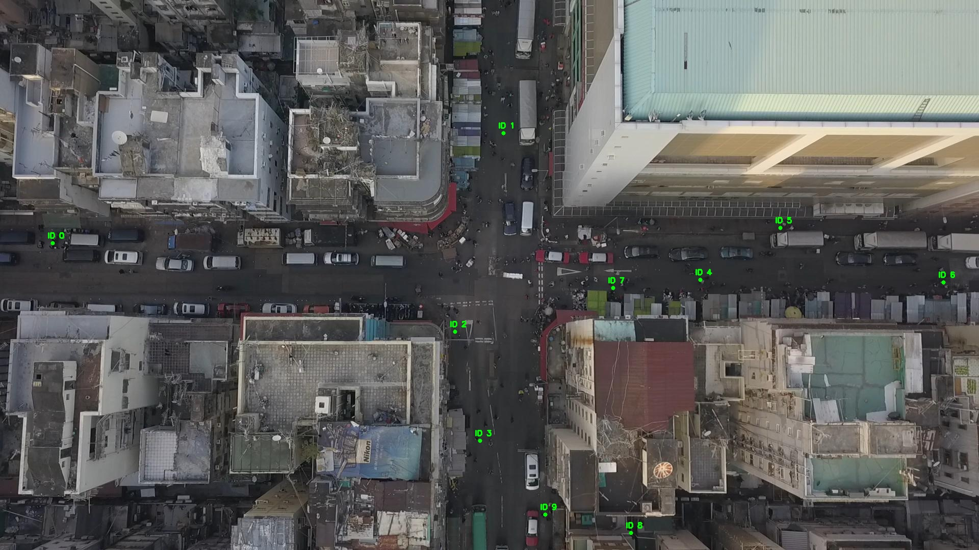

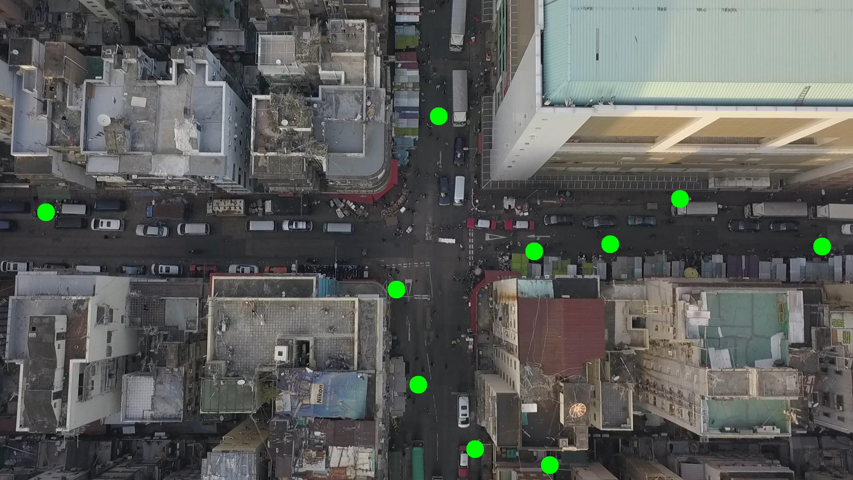

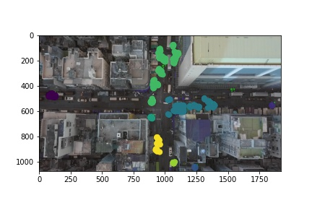

Silhouette metric for img011012.jpg is: 0.5812480842766266

Davies Bouldin metric for img011012.jpg is: 0.37377482777009596

Calinski Harabasz metric for img011012.jpg is: 21936.980109375563

ID 0: (103, 477)

ID 1: (988, 274)

ID 2: (889, 651)

ID 3: (942, 855)

ID 4: (1373, 549)

ID 5: (1530, 447)

ID 6: (1850, 554)

ID 7: (1185, 566)

ID 8: (1236, 1045)

ID 9: (1071, 1007)

